The Algebraic Approach

14.28 - The Algebraic Approach - Ordinary Least Squares
The statistical approach works well, and its computations are straightforward. You can even do them all by hand for relatively small data sets. Unfortunately, this simplicity breaks down when considering more than one input variable. There are many more things to compute in the case of 2 or more input variables. You might think that for two input variables, we would simply have to compute all the values we computed for a single input variable x twice. This, unfortunately, is not the case. As we add more input variables to the mix, we must keep track of the influence of each input variable x on y and each combination of input variables on y. For two parameters, this is still reasonably easy to manage, but beyond that, our tabular approach becomes cumbersome and inefficient. In this scenario, we can use the algebraic method of ordinary least squares (OLS). The main difference between the methods is that the first computes all necessary values by iterating over each pair of observations. It turns out that if we can represent these values not as single pairs of observations, but instead like vectors and matrices, many of the computations can be performed by straightforward matrix multiplications.

14.29 - From elements and lists to vectors and matrices
Think back to the chapter on transformations. There, we used a concise representation of a particular type of transformation that could be applied in one go to a matrix of points of arbitrary size. Take rotation, for example. Imagine we have a list of (x,y) data points centered around an origin of (0,0). Let's imagine we want to rotate each (x,y) data point around the origin by 45 degrees clockwise. This is computed for a single data point, as shown in Equation 14.15. Notice that we need a little helper equation to transform our rotation from degrees to radians, as in Equation 14.14).

(14.14)
(14.15)
(14.16)
Equations 14.14 to 14.16 - To rotate a 2D point given by (x,y) by a certain angle (45 degrees clockwise in our current example), we use Equations 14.15 and 14.16. We will need to convert our angle in degrees to radians (alpha) using Equation 14.14.

Of course, our computer program is happy to loop over each datapoint tuple (x,y) in list P and apply the rotation. That means we need an iterator, like a for loop or some modern version, see Code snippet 14.1. There is nothing inherently wrong with this implementation. However, we can perform the same computation using a single matrix multiplication operation. This greatly simplifies the math that needs to be converted into code. And if we are using a numerical package like NumPy, it also cleans up our code, removing the need for a for loop. Even better, although the computations performed at the CPU level is the same in the end, optimizations within NumPy and specialized hardware solutions like GPUs also significantly speed up the computation. And for large data sets, we will use them for training deep belief neural networks; these optimizations require us to train models within a reasonable time. Let's perform the same rotation using matrix multiplication.

 | import math  degrees = 45  alpha = degrees / 180 * math.pi  P_rotated = []  for i in range(len(P)):  x = P[i,0]  y = P[i,1]  x_rot = x \* math.cos(alpha) + y \* math.sin(alpha)  y_rot = x \* -math.sin(alpha) + y \* math.cos(alpha)  P_rotated.append((x_rot,y_rot)) | (14.1)
 | Code Snippet 14.1 - This code snippet uses core Python to compute the rotation specified in Equations 14.15 and 14.16.

First, we need to define our matrices, P and R. P is a n x 2 array, in which each row constitutes one datapoint with coordinates (xi,yi). The matrix R is a 2x2 square rotation matrix. If you want, you can work out how to construct this rotation matrix from Equation 14.15, but you can trust us that this is how one specifies a rotation around the origin in 2 dimensions, thanks to the work of great mathematicians like Euler, Laplace, LaGrange, Descartes, and many others. To rotate a 2D point given by (x,y) by a certain angle (45 degrees clockwise), we first convert the angle to radians using Equation 14.14. Second, we define our P matrix as an nx2 matrix where each row is a (x,y) coordinate (14.17), as well as our 2x2 rotation matrix (14.18). Computing the actual transformation across all points in P is done as a matrix multiplication operation (14.19). The python implementation is found in Code Snippet 14.2.
(14.17)
(14.18)
(14.19)
Equations 14.17 to 14.19 - We can rotate all points in one matrix operation using NumPy.

 | import NumPy as np  degrees = 45  alpha = degrees / 180 * np.pi  R = np.array([[np.cos(alpha),np.sin(alpha)],  [np.sin(alpha),np.cos(alpha)]]);  P_rotated = np.dot(P,R) | (14.2)
 | Code Snippet 14.2 - The NumPy variant of the code snippet is much more concise.

14.30 - Ordinary Least Squares
In the previous example, we replaced all that tedious indexing with a for loop with a single concise line of code to implement a rotation operating on a set of points. But how does this relate to finding the optimal parameters of a linear regression model, given some input and output data? In the same we were able to reformulate an iterative method of rotating each point by some angle in turn as matrix multiplication, giving us the same result, we can reformulate the statistical method of the previous section (also operating on one datapoint at a time) in a very similar way. This is called the ordinary least squares method, and its formula is written out in equation 14.20.

(14.20)
Equation 14.20 - The equation for Ordinary Least Squares (OLS), an algebraic method to estimate the optimal parameters beta, given an input matrix X and output matrix Y

In words, you can read Equation 14.20 as follows. The parameters associated with the optimal mapping of input data X onto output data Y are given by the inverse of the inner product of X transposed and X, multiplied by the transpose of matrix X, multiplied by matrix Y. Transposing a matrix means flipping its axes. So, a matrix of n x m because a matrix of m x n. In statistics, we sometimes refer to it as a pivot. An inverse of a matrix is a matrix of the same size that yields an identity matrix when multiplied with its original. Computing the inverse of a matrix is tricky, but it helps to understand what an inverse matrix can bring to the table. For example, if our original matrix is a transformation matrix, its inverse implements the same rotation but in the opposite direction. Did you rotate the point clockwise around the origin by 45 degrees using rotation matrix R? Well, you can use R⁻¹ (the inverse of R) to rotate them back to exactly where they were.
Compared to the simplicity of its formulation, the actual derivation is a little complex and beyond the scope of this course. The complexity is mostly because the algebraic formula requires us to estimate the inverse of a matrix, which isn't easily explained or done by hand if you are not familiar with inverses and how to compute them. But let us at least understand what data it is operating on. Notice that we have two variables in the equation: X and Y. X is like our P above. It is a matrix of size n x m. Each row n is a data point, and each column m is a variable or dimension of the data points. Going back to medical expenses data sets, X has n=20 rows of data points (remember we used only a small subset of the original data for transparency into some of our computations on it) and m=6 columns of variables (aka. predictors or regressors): age, number of children, region, smoking habit, BMI, and sex assigned at birth. Y here is the output data. In this instance, we consider Y a matrix, not a vector. A vector is one-dimensional and has n values. To make the equation work in python using NumPy, we do have to transform that vector into a matrix of n x 1. It is the same data; the only difference is that it has a matrix format of n x m, even if m =1.

14.31 - OLS on the medical expense dataset
We have introduced OLS as a more concise and optimized alternative to the statistical approach outlined in the previous section. Comparing Figure 14.17 with Figure 14.16 of the previous section, we can see both methods are indeed perfectly aligned in their outputs. At the very least, we should quickly verify both methods yield the same optimal parameters.

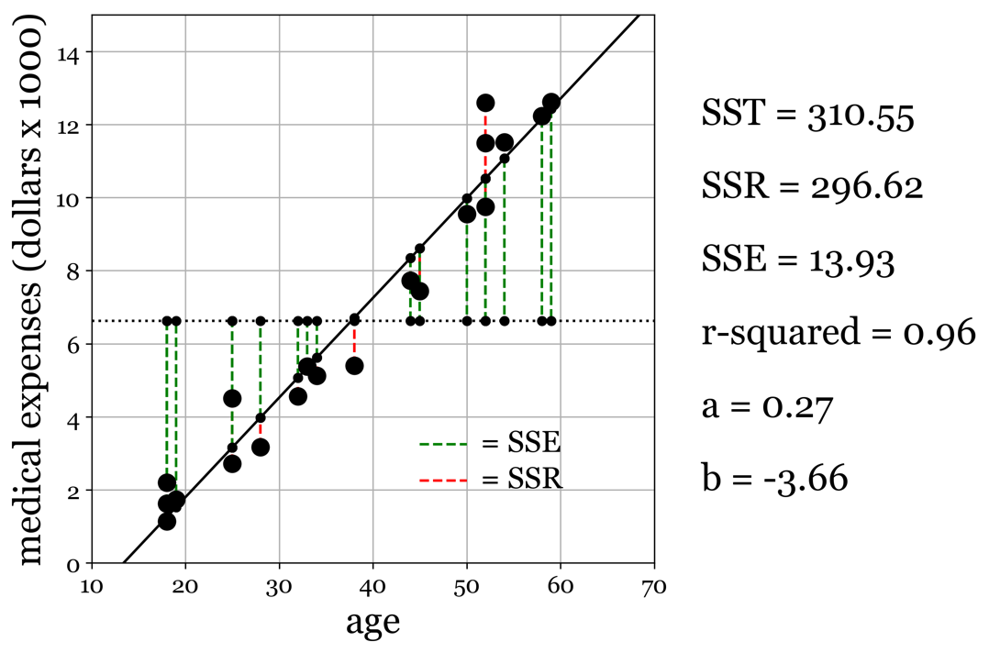
Figure 14.20 - Our regression model, computed using OLS. The mode is identical (as it should be) to the model found in Figure 14.18, based on fitting the data with the statistical approach to linear regression.

14.32 - More than just a concise algebraic solution
There are a few surprising benefits to using the OLS implementation. First, we are not restricted to having only a single input or an outcome. We can make both X and Y as multidimensional as we want. In our examples up to this point, we have always used a single input variable (age) to predict a single outcome variable (amount of medical expenses). Using OLS, we can simultaneously map input data with multiple dimensions onto outputs with many dimensions. For example, we can include all the variables of our data set as input variables (sex, age, smoking habits, region, BMI, and the number of children). Furthermore, we can use multiple outcome variables (medical expenses, credit card score, foreclosure probability), link all the inputs to all the outputs, and see which combination of inputs is most predictive of any of the outputs. Doing this is possible using the item-by-item statistical approach, but the amount of bookkeeping and keeping track of all combinations of variables and their associated statistics because too cumbersome and tedious very quickly. While at the same time, still only requiring that single formula expressed in Equation 14.15 to derive the optimal parameters of our regression model. Ordinary Least Squares has many applications outside of machine learning. We can use it to perform dimensionality reduction, mapping a set of input variables onto a set of so-called basis functions (we will see this in the chapter on dimensionality reduction). It can be used for filtering or for finding transformations of points between spaces. We could even reformulate some more exotic machine learning mythologies like graphs into the language of ordinary least squares and obtain insights into their structure and dynamics. For a strictly linear method, that is quite impressive.

